TITLE
First A. Authorª*, Second B. Authorª and Third C. Author^{b}
ª Department, University, City, Country
^{b} Department, University, City, Country
* first_last@email.edu
Keywords: alphabetical, lowercase except proper nouns, maximum six

Introduction – A level one heading
This document presents the instructions needed to prepare the extended abstract. The abstract should be no more than 1,500 words (excluding references) with clear statements on the objectives of the work and its novelty. We welcome completed research projects, work in progress, or visionary works that probe new directions in cartography and GIScience. We will notify authors of selected abstracts and a due date for conference registration. Authors must register the conference before we publicly announce the selection. The rest of the text in this template provides hints about properly generating the parts of your APA-formatted paper.
The document should start with the title, authors, authors’ affiliation and e-mail followed by the keywords (up to six). Please indicate the corresponding author with an asterisk. The text is Times New Roman, 12 point, single spacing. There is a 12pt space between paragraphs, a 12pt space after level 1 headings, and 24pt space above level 1 headings. The submission of the document should be made at the conference site on easychair (https://easychair.org/my/conference?conf=autocarto2020).

Method
As far as references go, DO NOT USE footnotes. For references, use the (Author, Date) style. For example, Smith (1990) indicated that cartography can be fun. That cartography is indeed fun, is clearly evident from the literature (Smith, 1990; Smith and Jones, 1991; Smith et al., 1992). To quote Smith, “cartography is great fun” (Smith, 1997, p. 187). Use the “et al.” form for more than two authors. An example of a second level heading is shown next, and heading levels three and four are included with the template, should you need them.

Dealing with tables and figures (example of heading 2 style)
Special attention should be devoted to making sure that figures and tables fit within the bounds of this page. Each figure should stand alone, with a caption and a reference in the text (Figure 1).
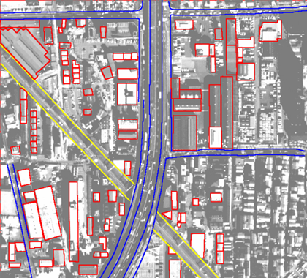
Figure 1: A gratuitous graphic. Use this caption style for figures and tables.
When you need to insert an equation, just go ahead and use the Word equation editor, for example:
$$A=πr^{2}$$

Results
There is no need to number equations, unless it is important to refer to them. Tables can be treated the same as figures, and be embedded into the Word file. They should be referred to in the text, and have their own number sequence, independent of figures. They also need captions. Avoid having figures and tables roll over or be split between pages. You can usually move them around until they appear on their own page. If not, you can force a new page using the Insert Tab and Break menu choice. Use the standard table tools in Word, or import the table from Excel or equivalent (Table 1).

Label | Distance (m) | Height (mm)
Aardvark | 99.4 | 32.3
Banana | 12.5 | 112.5
Caterpillar | 745.5 | 1,123.9
Table 1: A meaningless table.

Discussion and Conclusion
In cases where formatting is uncertain, use the sixth edition APA Style Guide (apastyle.org). Sample references are listed below, and are cited in APA format. We recommend when DOIs are available, that you include them. For more information about formatting references, Taylor and Francis provides a guide here: www.tandf.co.uk/journals/authors/style/reference/tf_APA.pdf.

Acknowledgements:
Funding sources and assistance from individuals.

References
Ajournalarticle, A. B., Junk, C. D., & Morejunk, E. F. (2019). Title of journal article goes here. Cartography and Geographic Information Science, 46, 195. doi: 10.1080/15230406.2019.1574554
B’Onlinesourcesareconfusing, S. O. (2010). Search for answers at apastyle.org and include issue numbers after volume numbers when there is no DOI. Journal of Articles Without Digital Object Identifiers, 127 (3), 816-826.
Cmagazinearticle, B. E. (2019, July). Note the last names on this page: Each source type has to be formatted in a different way. [Special issue]. Prose Magazine, 126 (5), 96-134.
Dbookreference, S. M., Orman, T. P., & Carey, R. (1967). Google scholar’s “cite” feature is usually accurate and time-saving. New York, NY: Pearson.
O’encyclopedia, S. E. (1993). Words. In The new encyclopedia Britannica (vol. 38, pp. 745-758). Chicago, IL: Penguin.
Pchapter, P. R., & Inaneditedvolume, J. C. (2001). Scientific research papers provide evidence of frustration with giant style manuals. In P. Z. Wildlifeconservation, R. Dawkins, & J. H. Dennett (Eds.), Research papers are hard work but boy are they good for you (pp. 123-256). New York, NY: Simon & Schuster.
Qosenberg, Morris. (1994, September 11). This is how you cite an online news article that has an author. The Washington Post. Retrieved from http://www.washingtonpost.com/dir/subdir/2014/05/11/a-d9-11e3_story.html

