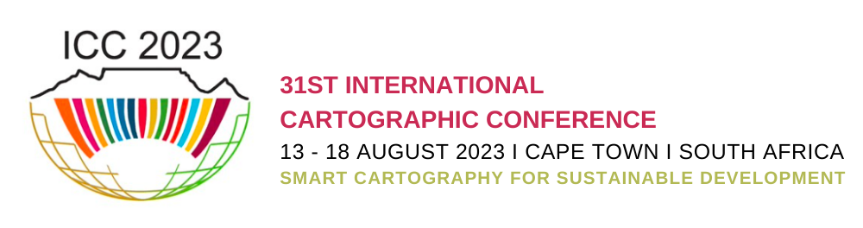
“The 19th General Assembly of the International Cartographic Association (ICA) and the 31th International Cartographic Conference (ICC 2023) will be held in Cape Town, South Africa from the 13th to 18th August 2023. The event is being organised by the South African National Committee for ICA. The world-class Cape Town International Convention Centre (CTICC), located in the beautiful coastal city of Cape Town has been selected as the main conference venue. (https://icc2023.org/)
The Cartographic Exhibition allows ICA National and Affiliate Members to showcase their recent cartographic material. The Cartographic Exhibition Catalogue includes descriptions of all exhibited items and is published with an ISBN. It will be available for download (PDF) from the conference website at least two weeks prior to the conference until the end of the conference. After the conference, the Catalogue will be available for download from the ICA website” (https://icc2023.org/wp-content/uploads/2022/10/ICC2023_CARTOGRAPHICEXHIBITION_GUIDELINES.pdf) .
- Items in the online exhibition will be accessible via the conference website, and they will also be displayed on screens at the conference venue.
- Items in the physical exhibition will be displayed on shelves, tables, and kiosks for the duration of the conference in an area designated for the Cartographic Exhibition.
Competition
All items displayed in the Cartographic Exhibition, except digital cartographic products and services, will be evaluated by:
a. a jury of international experts, and
b. a public vote.
Three winners per category will be decided by the jury vote. One winner per category will be decided based on the public vote. The jury may elect to aggregate, with explanation and motivation, the awards for any category.
Winning items will receive an ICA certificate and the right to use the ICA International Cartographic Exhibition Award Winner Logo. The awards will be presented at the Closing Ceremony of the conference.
All submissions will be assessed by a panel of experts who will select material for submission to the ICC 2023 exhibition and their decisions are final. The maximum number of items that can be submitted from South Africa is:
- Physical exhibition:
  - Atlases (max 3)
  - Educational cartographic products (max 3)
  - Physical cartographic products (max 3)
- Online exhibition (max 18)
For each item in the online exhibition:
Submit either the item (PNG, JPEG, PDF or TIFF) or in the case of an online item accessible via a URL, enter the URL for the video of the item (MP4) in a cloud folder (shared link). The LOC will download the video from this link and upload it to a YouTube channel from where it will be displayed in the online exhibition.
• The recommended file size for the item is 5MB, maximum 30MB.
• The maximum file size for the video of an online item accessible via a URL (MP4) is 100MB.
The video should be 2−4 minutes in length, describe the product, provide a visual tour of its features and functionality, and if possible, include a URL link at the end for viewers to link to the actual product. An audio component is encouraged although not required.
Available categories:
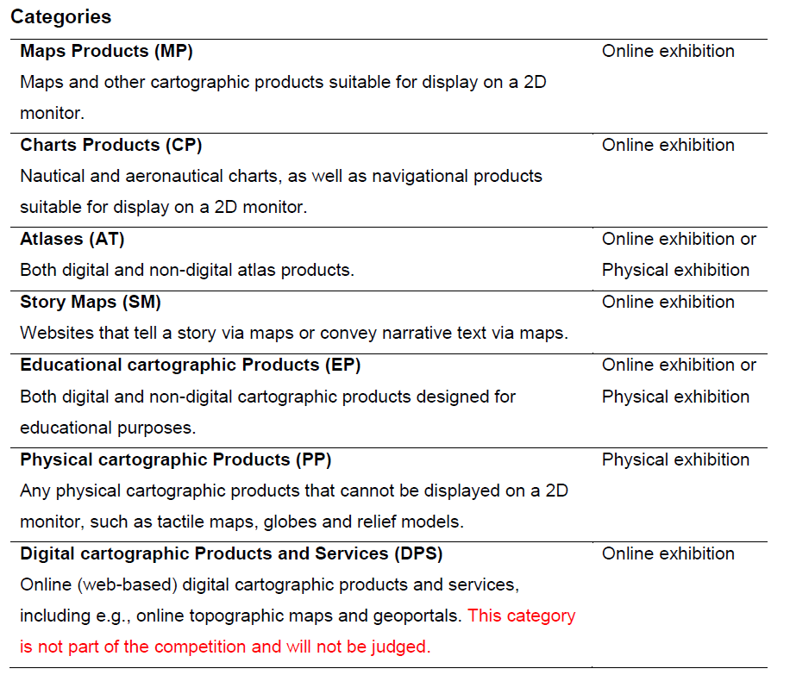
https://icc2023.org/index.php/international-map-exhibition/

Please note:
- All entries must be submitted to Aileen Buckley (abuckley@esri.com) by 15 April 2023.
- Submissions are invited of material that reflects recent work and must have been edited or modified after December 2021, as specified in the guidelines for the ICC 2023 map exhibition https://icc2023.org/index.php/international-map-exhibition/.
- A thumbnail image of each item is required for both the online and printed catalogue:
  - Online catalogue – a picture or screenshot of the item (PNG or JPEG) at 150 dpi or higher with the following dimensions: 1280px x 720px (landscape). The recommended file size is minimum 400KB, maximum 1MB.
  - Printed catalogue - A picture or screenshot of the item (PNG or JPEG) at 300 dpi with the following dimensions: 1920px x 1080px (landscape or portrait). The recommended file size is minimum 5MB, maximum 30MB. CMYK is preferable to retain the exact colors for printing.

- Please visit https://icc2023.org/ or https://icc2023.org/index.php/international-map-exhibition/ for more information.
Information required for each entry:
Map Products (MP)
Title (in English)
Author(s)
Published by
Date published
Language(s) used on legend
Copyright notice
Dimensions (mm) if relevant
Scale (if relevant)
Abstract/Description (100 words max in English)

Chart Products (CP)
Title (in English)
Author(s)
Published by
Date published
Language(s) used on legend
Copyright notice
Dimensions (mm) if relevant
Scale (if relevant)
Abstract/Description (100 words max in English)

Atlases (AT)
Title (in English)
Author(s)
Published by
Date published
Language(s) used on legend
Copyright notice
For physical exhibition: Dimensions (mm)
Number of pages
For online exhibition:
URL (if applicable)
Abstract/Description (100 words max in English)

Story Maps (SM)
Title (in English)
Author(s)
Published by
Date published
Language(s) used on legend
Copyright notice
Software with which the story map was developed
URL
Abstract/Description (100 words max in English)

Educational Cartographic Products (EP)
Title (in English)
Author(s)
Published by
Date published
Language(s) used on legend
Copyright notice
For physical exhibition: Dimensions (mm)
For online exhibition:
URL (if applicable)
Abstract/Description (100 words max in English)

Physical Cartographic Products (PP)
Title (in English)
Author(s)
Published by
Date published
Language(s) used on legend
Copyright notice
Dimensions (mm) if relevant
Scale (if relevant)
Abstract/Description (100 words max in English)

Digital Cartographic Product or Service (DPS)
Title (in English)
Author(s)
Published by
Date published
Language(s) used on legend
Copyright notice
Scale (if relevant)
Type e.g., app, DVD, web map, TMS/XYZ Tile, Google API, OGC web service
Operating system e.g., Windows, MacOS, Linux, Android, iOS
URL (if applicable)
Abstract/Description (100 words max in English)

